Data Structures

A data structure is basically a group of data elements that are put together under one name, and which defines a particular way of storing and organizing data in a computer so that it can be used efficiently. Data structures are used in almost every program or software system. Some common examples of data structures are arrays, linked lists, queues, stacks, binary trees, and hash tables.

Classification of data structures
Data structures are generally categorized into two classes: primitive and non-primitive data
structures.
Primitive and Non-primitive Data Structures
Primitive data structures are the fundamental data types which are supported by a programming
language. Some basic data types are integer, real, character, and boolean. The terms ‘data type’,
‘basic data type’, and ‘primitive data type’ are often used interchangeably.
Non-primitive data structures are those data structures which are created using primitive data
structures. Examples of such data structures include linked lists, stacks, trees, and graphs.
Non-primitive data structures can further be classified into two categories: linear and non-linear
data structures.
Linear and Non-linear Structures
If the elements of a data structure are stored in a linear or sequential order, then it is a linear data structure. Examples include arrays, linked lists, stacks, and queues. Linear data structures can be represented in memory in two different ways. One way is to have to a linear relationship between elements by means of sequential memory locations. The other way is to have a linear relationship between elements by means of links.
However, if the elements of a data structure are not stored in a sequential order, then it is a
non-linear data structure. The relationship of adjacency is not maintained between elements of a non-linear data structure. Examples include trees and graphs.

Operations on data structures
- Traversing It means to access each data item exactly once so that it can be processed. For example, to print the names of all the students in a class.
- Searching It is used to find the location of one or more data items that satisfy the given constraint. Such a data item may or may not be present in the given collection of data items. For example, to find the names of all the students who secured 100 marks in mathematics.
- Inserting It is used to add new data items to the given list of data items. For example, to add the details of a new student who has recently joined the course.
- Deleting It means to remove (delete) a particular data item from the given collection of data items. For example, to delete the name of a student who has left the course.
- Sorting Data items can be arranged in some order like ascending order or descending order depending on the type of application. For example, arranging the names of students in a class in an alphabetical order, or calculating the top three winners by arranging the participants’ scores in descending order and then extracting the top three.
- Merging Lists of two sorted data items can be combined to form a single list of sorted data items.
Structure of a C program
A C program contains one or more functions, where a function is defined as a group of statements that perform a well-defined task. Figure 1.1 shows the structure of a C program. The statements in a function are written in a logical sequence to perform a specific task. The main() function is the most important function and is a part of every C program. Rather, the execution of a C program begins with this function.
Data types in C
Data type determines the set of values that a data item can take and the operations that can be
performed on the item. C language provides four basic data types. The char data type is of one byte and is used to store single characters.
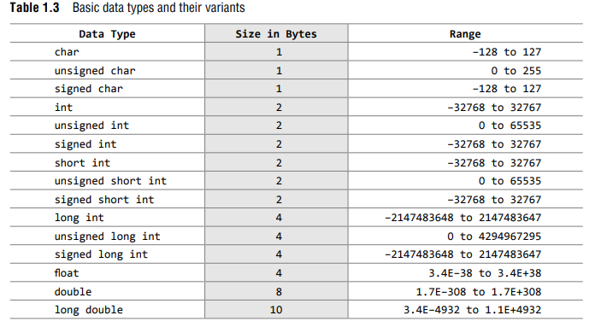

Abstract Data Types
Abstract Data type (ADT) is a type (or class) for objects whose behavior is defined by a set of value and a set of operations.
The definition of ADT only mentions what operations are to be performed but not how these operations will be implemented. It does not specify how data will be organized in memory and what algorithms will be used for implementing the operations. It is called “abstract” because it gives an implementation independent view. The process of providing only the essentials and hiding the details is known as abstraction. The user of data type need not know that data type is implemented, for example, we have been using int, float, char data types only with the knowledge with values that can take and operations that can be performed on them without any idea of how these types are implemented. So a user only needs to know what a data type can do but not how it will do it.
An abstract data type (ADT) is the way we look at a data structure, focusing on what it does and ignoring how it does its job
Stack ADT
A Stack contains elements of same type arranged in sequential order. All operations takes place at a single end that is top of the stack and following operations can be performed:
- push()-Insert an element at one end of the stack called top.
- pop() – Remove and return the element at the top of the stack, if it is not empty.
- peek() – Return the element at the top of the stack without removing it, if the stack is not empty.
- size() – Return the number of elements in the stack.
- isEmpty() – Return true if the stack is empty, otherwise return false.
- isFull() – Return true if the stack is full, otherwise return false.
Queue ADT
A Queue contains elements of same type arranged in sequential order. Operations takes place at both ends, insertion is done at end and deletion is done at front. Following operations can be performed:
- enqueue () – Insert an element at the end of the queue.
- dequeue() – Remove and return the first element of queue, if the queue is not empty.
- peek() – Return the element of the queue without removing it, if the queue is not empty.
- size() – Return the number of elements in the queue.
- isEmpty() – Return true if the queue is empty, otherwise return false.
- isFull() – Return true if the queue is full, otherwise return false.

Algorithms
Algorithm is a step-by-step procedure, which defines a set of instructions to be executed in a certain order to get the desired output. Algorithms are generally created independent of underlying languages, i.e. an algorithm can be implemented in more than one programming language.

Characteristics of an Algorithm
- Unambiguous − Algorithm should be clear and unambiguous. Each of its steps (or phases), and their inputs/outputs should be clear and must lead to only one meaning.
- Input − An algorithm should have 0 or more well-defined inputs.
- Output − An algorithm should have 1 or more well-defined outputs, and should match the desired output.
- Finiteness − Algorithms must terminate after a finite number of steps.
- Feasibility − Should be feasible with the available resources.
- Independent − An algorithm should have step-by-step directions, which should be independent of any programming code.

Efficiency of an algorithm
Analysing an algorithm means determining the amount of resources (such as time and memory) needed to execute it. Algorithms are generally designed to work with an arbitrary number of inputs, so the efficiency or complexity of an algorithm is stated in terms of time and space complexity. The time complexity of an algorithm is basically the running time of a program as a function of the input size. Similarly, the space complexity of an algorithm is the amount of computer memory that is required during the program execution as a function of the input size.
- The time complexity of an algorithm is basically the running time of the program as a function of the input size.
- The space complexity of an algorithm is the amount of computer memory required during the program execution as a function of the input size.
- The worst-case running time of an algorithm is an upper bound on the running time for any input.
- The average-case running time specifies the expected behaviour of the algorithm when the input is randomly drawn from a given distribution.
- Amortized analysis guarantees the average performance of each operation in the worst case.
- The efficiency of an algorithm is expressed in terms of the number of elements that has to be processed and the type of the loop that is being used.
- Worst-case running time This denotes the behaviour of an algorithm with respect to the worstpossible case of the input instance. The worst-case running time of an algorithm is an upper bound on the running time for any input. Therefore, having the knowledge of worst-case running time gives us an assurance that the algorithm will never go beyond this time limit.
- Average-case running time The average-case running time of an algorithm is an estimate of the running time for an ‘average’ input. It specifies the expected behaviour of the algorithm when the input is randomly drawn from a given distribution. Average-case running time assumes that all inputs of a given size are equally likely.
- Best-case running time The term ‘best-case performance’ is used to analyse an algorithm under optimal conditions. For example, the best case for a simple linear search on an array occurs when the desired element is the first in the list. However, while developing and choosing an algorithm to solve a problem, we hardly base our decision on the best-case performance. It is always recommended to improve the average performance and the worst-case performance of an algorithm.
Asymptotic Notations-
Asymptotic notations are the mathematical notations used to describe the running time of an algorithm when the input tends towards a particular value or a limiting value.
Big-O Notation (O-notation)- Big-O notation represents the upper bound of the running time of an algorithm. Thus, it gives the worst-case complexity of an algorithm.
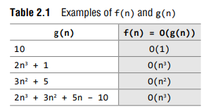
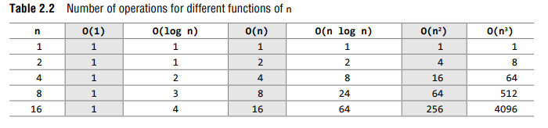
Omega Notation (Ω-notation)- Omega notation represents the lower bound of the running time of an algorithm. Thus, it provides the best case complexity of an algorithm.

Theta Notation (Θ-notation)- Theta notation encloses the function from above and below. Since it represents the upper and the lower bound of the running time of an algorithm, it is used for analyzing the average-case complexity of an algorithm.
{ 100 , log (2000) , 10^4 } belongs to Θ(1)
{ (n/4) , (2n+3) , (n/100 + log(n)) } belongs to Θ(n)
{ (n^2+n) , (2n^2) , (n^2+log(n))} belongs to Θ( n2)

ARRAY

An array is a collection of similar data elements. These data elements have the same data type.
The elements of the array are stored in consecutive memory locations and are referenced by an
index (also known as the subscript). The subscript is an ordinal number which is used to identify
an element of the array.
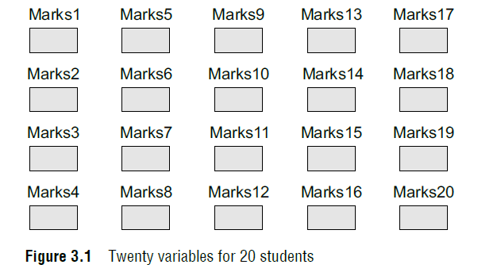
Declaration of arrays
Declaring an array means specifying the following:
Data type—the kind of values it can store, for example, int, char, float, double.
Name—to identify the array.
Size—the maximum number of values that the array can hold.
Types of arrays
- One dimensional array
- Multidimensional array
One dimensional array:
Arrays are declared using the following syntax:
type name[size];
The type can be either int, float, double, char, or any other valid data type. The number within
brackets indicates the size of the array, i.e., the maximum number of elements that can be stored
in the array. For example, if we write,
int marks[10];
then the statement declares marks to be an array containing 10 elements. In C, the array index
starts from zero. The first element will be stored in marks[0], second element in marks[1], and
so on. Therefore, the last element, that is the 10th element, will be stored in marks[9].
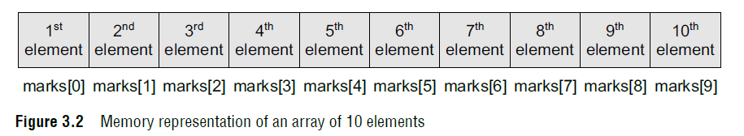
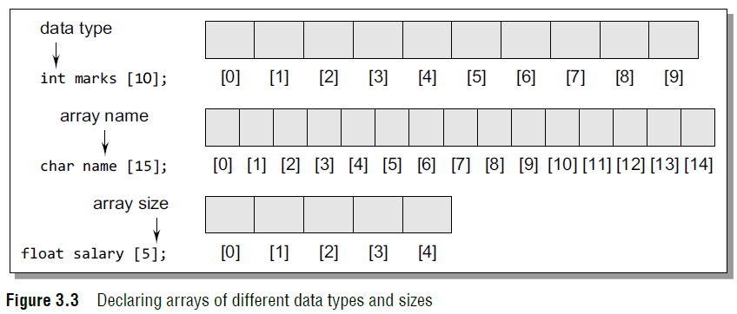
Accessing the elements of an array
// Set each element of the array to –1
int i, marks[1 ];
for(i= ;i<1 ;i++)
marks[i] = –1;
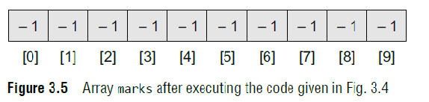
Two-dimensional arrays
One-dimensional arrays are organized linearly in only one direction. But at times, we need to store data in the form of grids or tables. Here, the concept of single-dimension arrays is extended to incorporate two-dimensional data structures.
A two-dimensional array is specified using two subscripts where the first subscript denotes the row and the second denotes the column. The C compiler treats a two dimensional array as an array of one-dimensional arrays.

Declaring Two-dimensional Arrays
Any array must be declared before being used. The declaration statement tells the compiler the
name of the array, the data type of each element in the array, and the size of each dimension. A
two-dimensional array is declared as:
data_type array_name[row_size][column_size];
Therefore, a two-dimensional m * n array is an array that contains m \ n data elements and each element is accessed using two subscripts, i and j, where i <= m and j <= n.
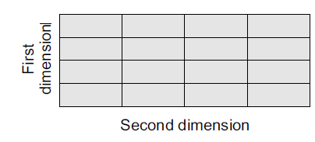

For example, if we want to store the marks obtained by three students in five different subjects, we can declare a two-dimensional array as:
int marks[3][5];
In the above statement, a two-dimensional array called marks has been declared that has m(3)
rows and n(5) columns. The first element of the array is denoted by marks[0][0], the second
element as marks[0][1], and so on. Here, marks[0][0] stores the marks obtained by the first
student in the first subject, marks[1][0] stores the marks obtained by the second student in the first subject.
The pictorial form of a two-dimensional array is shown below:
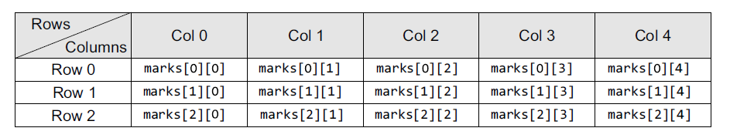
Hence, we see that a 2D array is treated as a collection of 1D arrays. Each row of a 2D array
corresponds to a 1D array consisting of n elements, where n is the number of columns.

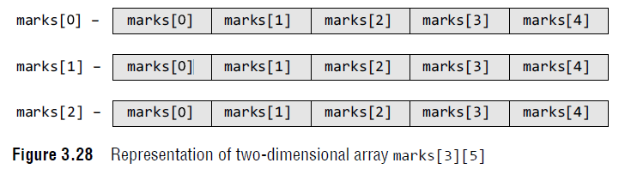

There are two ways of storing a two-dimensional array in the memory. The first way is the row major order and the second is the column major order.
In one-dimensional arrays, computer does not keep track of the address of every element in the array. It stores only the address of the first element and calculates the address of other elements from the base address (address of the first element). Same is the case with a two-dimensional array. Here also, the computer stores the base address, and the address of the other elements is calculated using the following formula.
If the array elements are stored in column major order,
Address(A[I][J]) = Base_Address + w{M ( J – 1) + (I – 1)}

And if the array elements are stored in row major order,
Address(A[I][J]) = Base_Address + w{N ( I – 1) + (J – 1)}

where w is the number of bytes required to store one element, N is the number of columns, M is the number of rows, and I and J are the subscripts of the array element.

Initializing Two-dimensional Arrays
A two-dimensional array is initialized in the same way as a one-dimensional array is initialized. For example,
int marks[2][3]={90, 87, 78, 68, 62, 71};

The above statement can also be written as:
int marks[2][3]={{90,87,78},{68, 62, 71}};

The above two-dimensional array has two rows and three columns. First, the elements in the
first row are initialized and then the elements of the second row are initialized. Therefore, marks[0][0] = 90 marks[0][1] = 87 marks[0][2] = 78
marks[1][0] = 68 marks[1][1] = 62 marks[1][2] = 71

Operations on two-dimensional arrays
Two-dimensional arrays can be used to implement the mathematical concept of matrices. In
mathematics, a matrix is a grid of numbers, arranged in rows and columns. Thus, using twodimensional arrays, we can perform the following operations on an m×n matrix:
- Transpose Transpose of an m*n matrix A is given as a n*m matrix B, where Bi,j = Aj,i.
- Sum Two matrices that are compatible with each other can be added together, storing the result in the third matrix. Two matrices are said to be compatible when they have the same number of rows and columns. The elements of two matrices can be added by writing
Ci,j = Ai,j + Bi,j
- Difference Two matrices that are compatible with each other can be subtracted, storing the result in the third matrix. Two matrices are said to be compatible when they have the same number of rows and columns. The elements of two matrices can be subtracted by writing:
Ci,j = Ai,j – Bi,j
- Product Two matrices can be multiplied with each other if the number of columns in the first matrix is equal to the number of rows in the second matrix. Therefore, m*n matrix A can be multiplied with a p*q matrix B if n=p. The dimension of the product matrix is m*q. The elements of two matrices can be multiplied by writing:
Ci,j = S Ai,kBk,j for k = 1 to n
Example Consider a 20 * 5 two-dimensional array marks which has its base address = 1000
and the size of an element = 2. Now compute the address of the element, marks[18][ 4] assuming
that the elements are stored in row major order.
Solution
Address(A[I][J]) = Base_Address + w{N (I – 1) + (J – 1)}
Address(marks[18][4]) = 1000 + 2 {5(18 – 1) + (4 – 1)}
= 1000 + 2 {5(17) + 3}
= 1000 + 2 (88)
= 1000 + 176 = 1176
Operations on arrays
There are a number of operations that can be performed on arrays. These operations include:
- Traversing an array- Traversing an array means accessing each and every element of the array for a specific purpose.
- Inserting an element in an array- adding an element in the array at a specific index location
- Searching an element in an array- finding the location of an element
- Deleting an element from an array- removing an element in the array at a specific index location
- Merging two arrays- combining two arrays into one single array
- Sorting an array in ascending or descending order
Three - Dimensional Array :
In three - dimensional array also address is calculated through two methods i.e; row-major order and column-major method.
To calculate address of element X[ i,j,k] using row-major order :
Location ( X[i,j,k] )=BA + MN (k-1) + N (i-1) + (j-1)
To calculate address of element X[ i,j,k] using column-major order
Location ( X[i,j,k] )=BA + MN (k-1) + M (j-1) + (i-1)
For example :
Given an array [ 1..8, 1..5, 1..7 ] of integers. Calculate address of element A[5,3,6], by using rows and columns methods, if BA=900?
Solution:- The dimensions of A are :
M=8 , N=5, R=7, i=5, j=3, k=6
Rows - wise :
Location (A[i,j,k]) = BA + MN(k-1) + N(i-1) + (j-1)
Location(A[5,3,6])= 900 + 8x5(6-1) + 5(5-1) + (3-1)
= 900 + 40 x 5 +5 x 4 + 2
= 900 + 200 +20 +2
= 1122
Columns - wise :
Location (A[i,j,k]) = BA + MN(k-1) + M(j-1) + (i-1)
Location (A[5,3,6]) = 900 + 8x5(6-1) + 8(3-1) + (5-1)
= 900 + 40 x 5 +8 x 2 + 4
= 900 + 200 +16 +4
= 1120

Let C be an n-dimensional array.
The length L( i ) of dimension i of C can be calculated by,
L(i)=upper bound - lower bound +1
For a given subscript K( i ) , the effective index E( i ) of L( i ) can be calculated from,
E(i)=K(i) - lower bound
Then address C[K(1),K(2),…,K(n) of element of C is,
Base (C) +w[(((…..(E(n)L(n-1)+E(n-1))L(n-2))+….+E(3))L(2)+E(2))L(1)+E(1)] , when C is stored in column major, and
Base (C)+w[(…((E(1)L(2)+E(2))L(3)+E(3))L(4)+…+E(n-1))L(n)+E(n)] , when C is stored in row major order.
Base (C) denotes the address of 1st element of C and w denotes the number of words per memory location.
For Row Major : BaseAddress + width* [(k-k0) * RC + (Total Number of Columns) * (i-i0) + (j-j0)]
For Column Major : BaseAddress + width * [(k-k0) * RC + (Total Number of Rows) * (j-j0) + (i-i0)]
where
k = current frame
k0 = initial frame
R = Total Number Of Rows
C = Total Number Of Columns
i = curent row index
i0 = initial row index
j = cuurent column index
j0 = initial column index

Final aktu question with solution
Address calculation in 2-D array: suppose A is a 2D array with dimensions M1 X M2. So that here total number of elements is equal to M1 X M2. Address should be calculated using one of the two methods as the following,
a. Row-by-Row
Location (A [j, k]) = Base (A) + w [N (j-1) + (k -1)]
Here, j and k indicates index value of the element whose address you want to search.Base (A) is the starting address of the given array. W is the memory word required to store given array’s element. Here, array is the of size M(rows) X N(columns).
b. Column-by-Column
Location (A [j, k]) = Base (A) + w [M (k-1) + (j -1)]
Here, j and k indicates index value of the element whose address you want to search.Base (A) is the starting address of the given array. W is the memory word required to store given array’s element. Here, array is the of size M(rows) X N(columns).
Examples:
1. Consider 30 X 4 2D arrays and base address is 200 and 1 word per memory locations. Find out the address of A (15, 3).
Base (A), M =30, N=4, j=15, k=3, w=1
a. Row-by-row
Location (A [j, k]) = Base (A) + w [N (j-1) + (k -1)]
Location (A [15, 3]) = 200 + 1 [4 (15 - 1) + (3 - 1)]
= 200 + 1 [56 + 2]
= 200 + 58
=258
b. Column-by-column
Location (A [j, k]) = Base (A) + w [M (k-1) + (j -1)]
Location (A [15, 3]) = 200 + 1 [30 (3 – 1) + (15 – 1)]
= 200 + 1 [30 (2) + 14]
= 200 + 74
=274
ii. Address calculation in multidimensional array: Suppose A is a 3D array of size M1 X M2 X M3. So total number if elements are M1 X M2 X M3. In 3D array lower bound (LB) is not always zero (0). It can be any number. Base address of any row of matrix is called effective address.
For example, A [2:11] indicates that A is a 1D array with lower bound 2 and upper bound (UB) 11.
A [2:11, 3:15] indicates that A is a 2D array with lower bound (LB) of row is 2 and Upper Bound (UB) of row is 11. In the same way lower bound (LB) of column is 3 and upper bound (UB) of column is 15.
Length of each dimension is equal to L_{i} = UB – LB +1
Lower bound (LB) is not always started with zero (0). So, we have to calculate effective address of each value.
Effective Address (E_{i}) = K_{i} - LB
Real address of any element is calculated as follows,
Row-by-Row: Base (A) + W [(E₁L₂ +E₂) L₃ + E₃]
Column-by-column: Base (A) + W [(E₃L₂ + E₂) L₁ + E₁)
Example: Suppose multidimensional array A and B are declared using A [-2:2, 2:22] and
B [1:8, -5:5, -10:5].
1. Find out the length of each dimension and number of elements in array A and B.
2. Consider B [3, 3, 3] elements in array B find effective address E1, E2 and E3. Also find out the real address of these elements. (In this case the base address of array B is 400 and W is 4)
Answer: For array A
L₁ = UB –LB +1 L₂ = UB –LB +1
=2 – (-2) +1 =22 – 2 + 1
= 4 + 1 = 5 = 21
For array B
L₁ = UB –LB +1 L₂= UB –LB +1 L₃= UB –LB +1
= 8 – 1 + 1 = 5 – (-5) +1 =5 – (-10) +1
= 8 = 11 = 16
Total number of elements in array B is: L₁ X L₂ X L₃ = 8 X 11 X 16 = 1408.
Here in given question K_{i} = 3, 3, 3 therefore K₁=3, k₂ = 3 and K₃ = 3
LB₁= 1, LB₂ = -5 LB₃ = -10
E₁ = K₁ – LB₁ = 3 – 1 = 2
E₂ = K₂ – LB₂ = 3- (-5) = 8
E₃ = K₃ – LB₃ = 3 – (-10) = 13
The real address Row – by- Row:
= Base (A) + W [ (E₁L₂ + E₂) L₃ + E₃]
= 400 + 4 [(2 (11) + 8) 16 + 13]
= 400 + 4 [(22+8) 16 + 13]
= 400 + 4 [(30) 16 + 13]
= 400 + 4 [480 + 13]
= 400 + 4 [493]
= 400 + 1972
= 2372
The real address Column – by – column:
= Base (A) + W [(E₃L₂ +E₂) L₁ + E₁]
= 400 + 4 [(13(11) + 8) 8 + 2]
= 400 +4 [(143 + 8) 8 + 2]
= 400 + 4[(151) 8 + 2)]
= 400 + 4[1208 + 2]
= 400 + 4840
= 5240
Sparse Matrix: It is a matrix with relatively high proportion of zero (0) values called sparse matrix. But these zero values occupy lots of memory. So, sparse matrix must be converted to some form which contains only non-zero values.

